Case Name:
County: Case No:

Firearm Identification Worksheet
(You may attach this to the petition.)

1. Does the restrained person [ ] own or [ ] have access to any firearms?
[ ] Yes [ ] No [ ] I don't know
Explain how they may have access:

2. Does the restrained person purchase, own, or have access to parts that could be assembled into a working firearm (example: ghost guns)?
[ ] Yes [ ] No [ ] I don't know

3. Does the restrained person have a concealed pistol license (CPL)?
[ ] Yes [ ] No [ ] I don't know

4. When was the last time you saw the firearm/s?

5. Do you know where the restrained person keeps the firearm/s?
[ ] Yes [ ] No
If yes, check all that apply:
[ ] On their Person [ ] In their Car [ ] In their Home [ ] Storage Unit [ ] In a Safe

6. To the best of your knowledge, are the guns typically loaded?
[ ] Yes [ ] No [ ] I don't know

7. How important are the firearms to the restrained person?
[ ] 1 (not very important) [ ] 2 [ ] 3 [ ] 4 [ ] 5 (very important) [ ] I don't know

8. What does the restrained person generally use the firearms for, if known? (check all that apply)
[ ] Hunting [ ] Collecting [ ] Target Shooting [ ] Protection [ ] Other:

9. Does the respondent possess explosives?
[ ] Yes [ ] No [ ] I don't know

10. Does the restrained person own or possess any other dangerous weapons you believe should be surrendered?
[ ] Yes [ ] No [ ] I don't know If yes, list them here:

The pictures below are examples of the most common guns. If you recognize any of the pictures below as similar to the one/s the restrained person has, please check it and write in how many they have of each.
[ ] Handgun (how many)  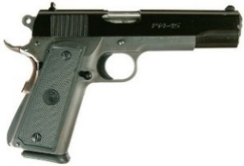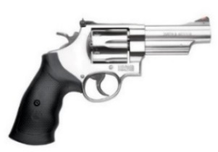  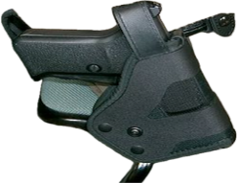 | [ ] Unassembled Firearm (how many)  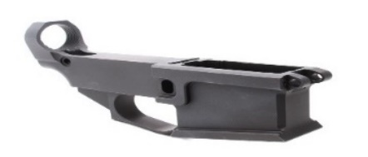
[ ] Semi-automatic Rifle (how many)
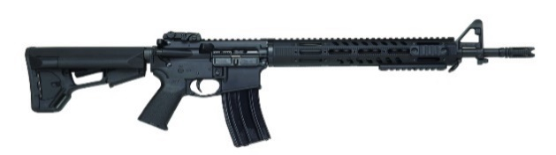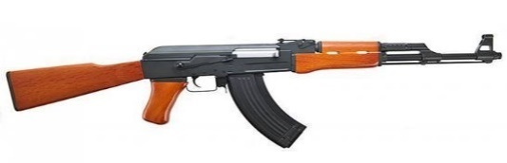
[ ] Rifle/Shotgun (how many)
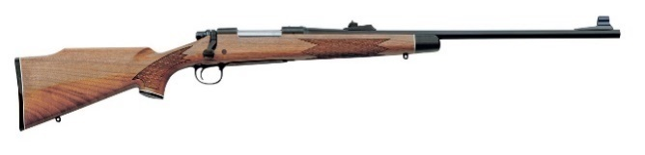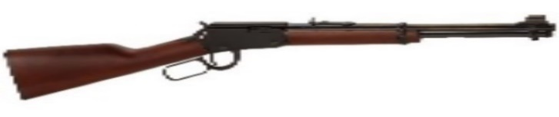
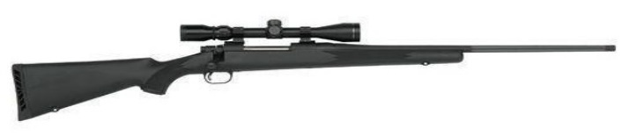
[ ] Other firearm/s (describe):

Sign here Print name Date

